**DRAFT**

**35-year population trends of Colorado butterfly plant**

**(*Oenothera* *coloradensis;* Onagraceae), a short-lived riparian species on**

**F. E. Warren Air Force Base, Laramie County, Wyoming**

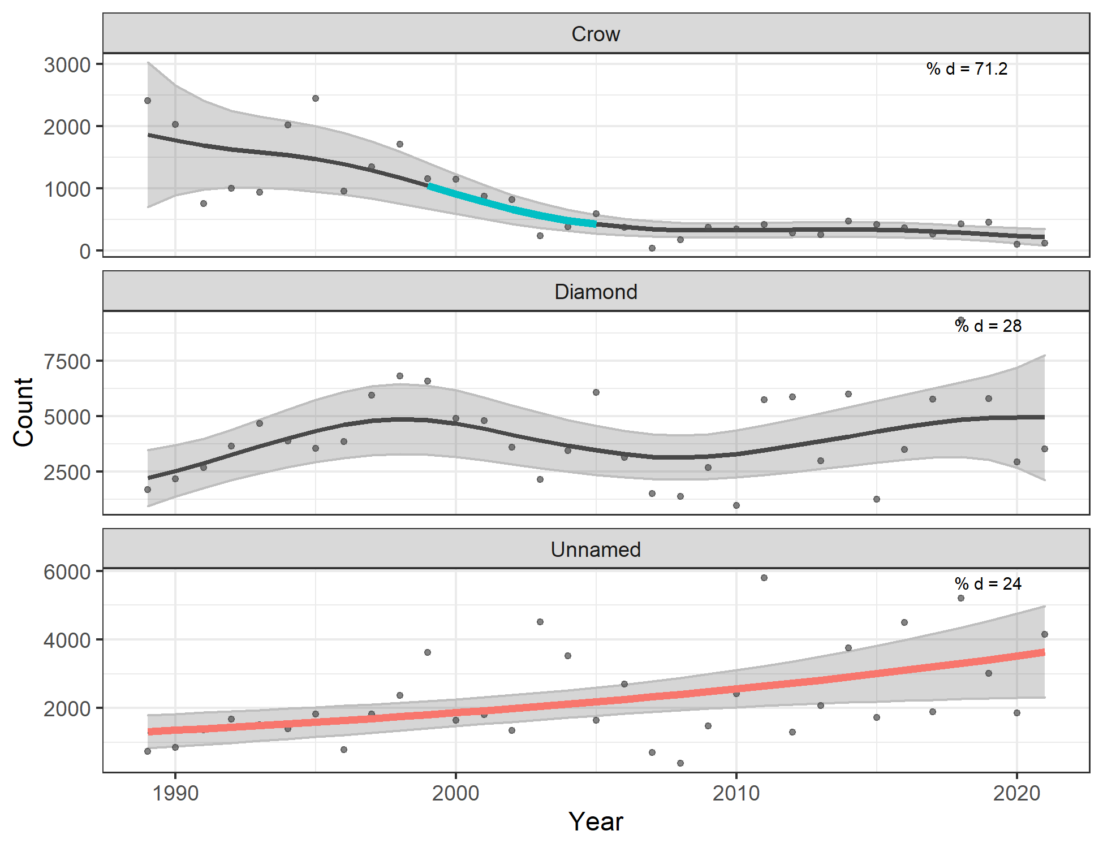

Prepared for

Alex Schubert

U.S. Fish and Wildlife Service

300 Vesle Drive

F. E. Warren Air Force Base, Wyoming 82005

By Bonnie Heidel¹ and Dorothy Tuthill²

Wyoming Natural Diversity Database

University of Wyoming

Laramie, WY 82071

May 2023

Agreement No. F19AC00730

¹Wyoming Natural Diversity Database

²Biodiversity Institute

### ABSTRACT

Annual census of Colorado butterfly plant (*Oenothera coloradensis* (Rydberg) W.L.

Wagner & Hoch) was initiated in 1986 and conducted consecutively for 35 years from 1988-2022 on F. E. Warren Air Force Base (FEWAFB), in Laramie County, Wyoming. The FEWAFB population of Colorado butterfly plant is the only one on federal land and is on three connected creek drainages with different hydrologies. The cumulative census results are presented using generalized additive models. The latter approach enabled us to estimate curvilinear trends and identify significant periods of change for the whole Base population, three creek subpopulations, and smaller creek segments. Population trend data show that the COBP population on the Base differs between subpopulations, with increases on two of three creeks, accompanied by increasing variability over time, and decrease on the mainstem creek with decreasing variability. Likewise, trend outcome would differ depending on the time interval, with the population and each subpopulation in decline between 1999-2008. Simulated population scenarios using Population Viability Analysis (PVA) modeling are being prepared to project prolonged population and subpopulation trends from past monitoring years for extended periods into the future. Results inform Post-Delisting Monitoring (PDM) and evaluation of PDM metrics as contribution to overall conservation and recovery under the Endangered Species Act.

Citation for this report: Heidel, B. and D. Tuthill. 2023. 35-year population trends of Colorado butterfly plant (*Oenothera* *coloradensis;* Onagraceae), a short-lived riparian species on

F. E. Warren Air Force Base, Laramie County, Wyoming. Prepared for U.S. Fish and Wildlife Service and F. E. Warren Air Force Base by the Wyoming Natural Diversity Database (University of Wyoming), Laramie, WY.

On the cover: Trends in Colorado butterfly plant (*Oenothera coloradensis*) creek subpopulations at F.E. Warren Air Force Base, Wyoming, 1989–2021 using the generalized additive model.

Table of Contents

INTRODUCTION 1

Overview 1

Life history 1

Population biology 1

STUDY AREA 2

Location 2

Climate 3

METHODS 6

Field census 6

Data analysis 6

RESULTS 7

Census results 7

DISCUSSION 12

2021 Monitoring plans 13

ACKNOWLEDGEMENTS 13

LITERATURE CITED 14

TABLES AND FIGURES

Table 1. Summary statistics for generalized additive models of trends in populations of Colorado butterfly plant (*Oenothera coloradensis*) at F.E. Warren Air Force Base, Wyoming, 1989-2021

Figure 1. Distribution of Colorado butterfly plant (*Oenothera coloradensis*) habitat on F. E. Warren Air Force Base

Figure 2. Precipitation totals and temperature averages in Cheyenne, WY (1984-2022)

Figure 3. Crow Creek annual stream flow (1993-2018).

Figure 4. Trends in Colorado butterfly plant (Oenothera coloradensis) overall population numbers at F. E. Warren Air Force Base, by decade and by creek, Cheyenne, Wyoming, 1989-2022

Figure 5. Trend in the population of Colorado butterfly plant (*Oenothera coloradensis*) at F. E. Warren Air Force Base, Wyoming, 1989-2021 and on the three creek subpopulations, using generalized additive model

Figure 6. Trends in creek subpopulation segments of Colorado butterfly plant (*Oenothera coloradensis*), 1985-2022

APPENDIX

Appendix A. Colorado butterfly plant(*Oenothera coloradensis*)census numbers on F. E. Warren Air Force Base (1986, 1988-2022)

Appendix B. Colorado butterfly plant (*Oenothera coloradensis*) census results on F. E. Warren Air Force Base riparian subunits (1986, 1988-2022)

Appendix C. Colorado butterfly plant (*Oenothera coloradensis*) census by polygon - raw data on F. E. Warren Air Force Base (2002-2022)

Appendix D. Colorado butterfly plant (*Oenothera coloradensis*) distribution on F. E. Warren Air Force Base, highlighting 2022 distribution

# INTRODUCTION

## Overview

Colorado butterfly plant (*Oenothera coloradensis* (Rydberg) W.L. Wagner & Hoch; syn. *Gaura neomexicana* Woot. ssp. *coloradensis* (Rydb.) Raven & Gregory) is a regional endemic of the North and South Platte River watersheds on the high plains of northeastern Colorado, western Nebraska and southeastern Wyoming. It was listed as Threatened under the Endangered Species Act in 2000 (USFWS 2000). Recently it was delisted due to discovery of additional populations since its listing and due to monitoring data that provided evidence of resiliency and capacity for rebounding from low numbers (USFWS 2019).

The Colorado butterfly plant (COBP) population on F. E. Warren Air Force Base (FEWAFB) is one of the three largest populations, the only one on federal land and the only under idle conditions. It has the longest monitoring record, initiated in 1986 and repeated annually from 1988-2022[1], before, during and after federal designation. Occupied COBP habitat on FEWAFB includes riparian settings along perennial, seasonal and ephemeral creeks. These conditions epitomize the range of occupied habitat across the species’ range.

A Post-Delisting-Monitoring (PDM) plan was established before de-listing (USFWS 2017) to monitor trends for at least five years at a sample of populations spanning the species’ distribution to compare the range, mean and median of population counts with compiled data to assess recovery against a benchmark. This report represents 2021 monitoring, the second year in PDM at one of the monitored populations. It is submitted in advance of a population viability analysis (PVA) using the same data (Wepprich et al. 2022).

## Life history

COBP was first reported to be a biennial (Raven and Gregory 1972), but demographic monitoring suggests that it is a short-lived perennial (Floyd 1995a, Floyd and Ranker 1998). COBP reproduces strictly by seed, growing into vegetative plants as a rosette of flat leaves appressed to the ground, and in later years sending up a flowering stalk that flowers once and dies. Germination and bolting both start in the first half of the growing season.

## Population biology

The distribution of COBP on FEWAFB has variously been referred to as representing one, two, or three populations, on Crow Creek and its two tributaries. We refer to it as one population comprised of three subpopulations because the species’ distribution is confluent on two creeks, was likely to have been confluent on the third creek prior to establishment of the Base, and the creeks are within 1.5 km of one another. There is high likelihood of genetic exchange via lepidopteran pollination vectors traveling between creeks. This is consistent with genetics results to date that include Inter-simple Sequence Repeat (Brown 1999, 2000; Tuthill and Brown 2003) and earlier gel electrophoresis (Floyd 1995a).

# STUDY AREA

## Location

The study area is located on FEWAFB immediately west of Cheyenne (41° 07’N 104° 52’W) in Laramie County, Wyoming. COBPoccupies riparian habitat along Crow Creek, Diamond Creek, and an unnamed, ephemeral creek (hereafter referred to as Unnamed Creek) (Figure 1). The creeks span approximately 5.1 km (3.2 miles) of riparian corridor habitat. Distribution of COBP is discontinuous and the cumulative occupied habitat is about 5 ha (12.4 ac). The creeks are low-gradient drainages at 1862-1887 m (6110-6190 ft) elevation with a relief of about 5.7 m per km (ca 30 ft per mile). Most occupied habitat is undeveloped and relatively undisturbed on FEWAFB.



Starting in 1989, COBP annual census results on FEWAFB were subdivided into 15 creek segments to help detect local differences that might help explain trends. The occupied COBP habitat within any given segment has some level of similarity in hydrology and other environmental attributes. Some segments represent large areas of occupied habitat and others are tiny. Segments are sequenced from upstream to downstream. A map and descriptions of the 15 creek segments occupied by COBP is presented in Appendix A with eight segments on Crow Creek (C1-C8), five segments on Diamond Creek (D1-D5), and two segments on Unnamed Creek (U1-U2).

Figure 1. Distribution of Colorado butterfly plant (*Oenothera coloradensis*) habitat on F. E. Warren Air Force Base, Cheyenne, Wyoming

### Hydrology and Habitat

Crow Creek is the largest of the three creeks occupied by COBP plant on FEWAFB. Diamond Creek and Unnamed Creek are its tributaries. It has perennial flow, a large watershed, and impoundments that include the municipal water source for Cheyenne. Though climate is uniform across FEWAFB, hydrology differs between creeks, as do associated soils and vegetation. Thus, we treat the three creeks as effective COBP subpopulations of one population.

The Crow Creek riparian corridor lies in a broad, gentle valley with occupied habitat at margins of wetland thicket dominated by *Salix exigua* (coyote willow), open woodland, and wet meadow. The Diamond Creek riparian corridor lies below a relatively steep, north-facing valley slope with occupied habitat in wet meadows and a narrow, wooded segment at the mouth. The Unnamed Creek riparian corridor lies in open plains with almost no valley relief, and occupied habitat is mainly wet meadows.

The riparian areas of the three creeks on FEWAFB have calcareous, fine loams that include Fluvaquentic Andoaquolls of the Merden series and frigid Cumulid Enoaquolls in the Kovich series (Stevenson 1997), i.e., subirrigated mollisols (Fertig 2000a). Crow Creek soils are relatively coarse loamy sands that are nutrient-poor, while Diamond Creek and Unnamed Creek have relatively fine sandy loams that have higher nutrient, mineral and organic content (Heidel 2007).

Botanists monitoring COBP since 1986 noted certain species becoming more abundant over time. Large increases in *Cirsium arvense* (Canada thistle), *Euphorbia esula* (leafy spurge), and *Salix exigua* (e.g., Marriott 1988, Marriott and Jones 1988, Fertig 2000b) occurred in the 1990’s through about 2007, particularly on Crow Creek. Woody cover and stature increased on Crow Creek in particular, as evidenced by photo point comparisons between 1984-2006 and surface cover changes evident in comparing aerial imagery between 1941-2000 (Heidel 2007). Since 2007, botanists noted a dieback in *S. exigua* on Crow Creek and native species have become increasingly common particularly on Diamond and Unnamed creeks including: *Carex praegracilis* (clustered field sedge), *Muhlenbergia richardsonis* (mat muhly), *Schizachyrium scoparium* (little bluestem), *Panicum virgatum* (switchgrass), and *Spartina pectinata* (prairie cordgrass) first noted in 2010 (Heidel and Handley 2011).

Land use history of the FEWAFB riparian corridor habitat is discussed in Heidel et al. (2019). Most habitat differences and some land uses differ between creek segments. Starting in 1989, COBP annual census results on FEWAFB were subdivided into 15 creek segments to help detect local differences that might help explain Base-wide trends. The occupied COBP habitat within any given segment is relatively similar in hydrology and other environmental attributes. A map of the 15 creek segments occupied by COBP is presented in Figure 2, including eight segments on Crow Creek (C1-C8), five segments on Diamond Creek (D1-D5), and two segments on Unnamed Creek (U1-U2). Text describing each creek segment is in Appendix A.

## Climate

FEWAFB has a continental climate typical of the high plains. The National Oceanic and

Atmospheric Association climate station closest to FEWAFB is at the Cheyenne Municipal

Airport, located 4.3 km (2.7 miles) northeast of FEWAFB at the same elevation (Station 481675; USDI NOAA 2012). The average annual precipitation during recent years (1984-2014) was 39.2 cm (15.6 inches), with heaviest rainfall in May, followed by June and July (USDI NOAA 2015). The average annual temperature over this same period was 7.9 °C (46.3 °F), peaking in July.

Meteorological trends are context for population trends. Growing season temperatures and total monthly precipitation values for early and late in the growing season (April-June and July-September, respectively) are represented in Figure 2 (USDI NOAA 2022). These periods were selected in keeping with statements that seedling establishment is a critical life history stage that may depend on adequate summer moisture (Fertig 2000). The data show an overall pattern of rising summer temperatures and diminishing summer precipitation, but relatively stable spring conditions. Tests have also been run using annual water year data (October-September of following year) and Crow Creek stream flow data (USGS 2018).



Figure 2a and 2b. Precipitation totals (in.) in Cheyenne, WY (1984-2022) for the early growing season (spring; April-June) and the late growing season (summer; July-September).







Figure 2c and 2d. Mean monthly temperature (°F) in Cheyenne, WY (1984-2022) for the early growing season (spring; April-June) and the late growing season (summer; July-September).

Characterization of FEWAFB climate conditions and their influence on COBP using monthly datasets can be confounded by short-term weather events and anomalous months. For example, the start of COBP monitoring was preceded by a flood on August 1, 1985 that was classified as a 100-year flood event (USDI Geological Survey 1989) and shows up as a summer spike in 1985 precipitation (Figure 2). There are also localized weather events associated with storm cells that can affect parts of the population differently such as hail damage.

Annual meteorological trends have annual oscillation and gradual shifts, but annual streamflow trends have been episodic (Figure 3; USGS 2018). Crow Creek is the only perennial stream on FEWAFB with a major watershed that includes the municipal water source for the City of Cheyenne, and intervening irrigation use. While streamflow data collection as average daily discharge are no longer collected on it, the monitoring period encapsulates a prolonged period of drought between 1999-2008.

Figure 3. Crow Creek annual stream flow (1993-2018). USGS stream monitoring site at upper end of Crow Creek at FEWAFB border (USGS site no. 06755950)

# METHODS

## Field census

Annual census of flowering COBP was initiated in 1986 by Hollis Marriott through Wyoming Natural Diversity Database (WYNDD; Marriott 1988) to gauge overall population trends under Research Natural Area objectives. It was timed during or after peak flowering in August or early September. After a pause in 1987, it was repeated in 1988 and then data collecting was partitioned into creek-segment subsets in 1989. The creek segment level of data analysis was the scale used in this report, although starting in 2002, we started mapping and recording census results as points and polygons, mapped using Global Positioning System units with generally 10 m or greater separation distance. The 2021 census signified the 34th consecutive year, consistent with Heidel and Tuthill (2020, 2021) and prior years.

The 2022 census was conducted by Bonnie Heidel and Dorothy Tuthill over the course of five days between 1-5 August. By census time, all plants producing flowering stems were detectable, despite herbivory or breakage. Most were in flower with fruits that had started to form or already fallen. In this report, all reproductive plants are referred to as flowering plants.

## Data analysis

COBP census results recorded as raw data stored by point or polygon that were compiled for each creek (Appendix B) and creek segment (Appendix C) from a master table (Appendix D). Results were summarized by presence/absence values in a map (Appendix E). Census results were plotted directly and in log(lambda). We also explored non-linear trends in abundance of COBP over the study period with generalized additive models (GAMs). This approach enabled us to estimate curvilinear trends and identify significant periods of change within trends for the population and subpopulations. We fit separate GAMs for the annual counts at each creek, creek segment, and the full population as smoothed functions of year. All models used a log link function and a negative-binomial error structure to account for over-dispersion in the count data. We selected the smoothing parameter (*k*) by refitting models with increasing values of *k* until the effective degrees of freedom (edf) remained stable (Wood et al. 2011), and assessed goodness of fit and serial auto-correlation by examining residual plots. To identify periods of change within each curvilinear trend, we estimated the first derivative of the trend line with 95% point-wise confidence intervals (CI) and interpreted periods when CI did not overlap zero as evidence that the slope was significantly different from zero (Curtis and Simpson 2014). We fit GAMs using restricted maximum likelihood functions with the mgcv package (version 1.8-28; Wood 2011) in the statistical software program R (version 3.6.1; R Development Core Team 2014). While our analyses were conducted piece-wise, we suggest future efforts consider using hierarchical GAMs to explore non-linear variation at the nested spatial scales of creeks and segments in a single model of the full dataset.

# RESULTS

## Census results

COBPnumbers increased on FEWAFB since the start of monitoring (Figure 4). The average number of plants was 6,960 plants for the continuous 35-year period. The 2022 tally of 5,123 plants was 73.6% of average. Decadal COBP trends were much stronger than the cumulative 35-year trend, increasing in the first decade, decreasing in the second decade, and increasing at a lower rate in the most period, and also with higher variability. Trends differed between creeks. COBP subpopulation numbers on Diamond and Unnamed Creeks showed increases over the 35-year period but those on Crow Creek showed decrease.

Figure 4. Trends in Colorado butterfly plant (*Oenothera coloradensis*) overall population numbers at F. E. Warren Air Force Base, by decade and by creek, Cheyenne, Wyoming, 1989-2022

Earlier data in a log(Lambda) analysis showed the overall negative density-dependence of numbers from one year to the next (Figure 4 in Heidel et al. 2022). There was increase in density-dependence on Diamond and Unnamed creeks over time whereas the most pronounced trend on Crow Creek was the plummet in COBP numbers in 2007 concurrent with flea beetle outbreak (Heidel et al. 2011).

Earlier GAM analysis of COBP population numbers are a more realistic representation of trends than linear regression lines. They showed non-linear trends with significant periods of change for the creek subpopulations and creek segments, but not for the population as a whole (Figure 5 in Heidel et al. 2022, reprinted below). The Crow Creek subpopulation fluctuated in the early years of the study, with a high of 2,448 plants in 1995, then experienced a significant period of decline from 1,708 plants in 1998 to 38 plants in 2007 and 175 plants in 2007, followed by a sustained period of low numbers through 2021 (Figure 5). Segment 6 was the only Crow Creek segment without a significant period of decrease.

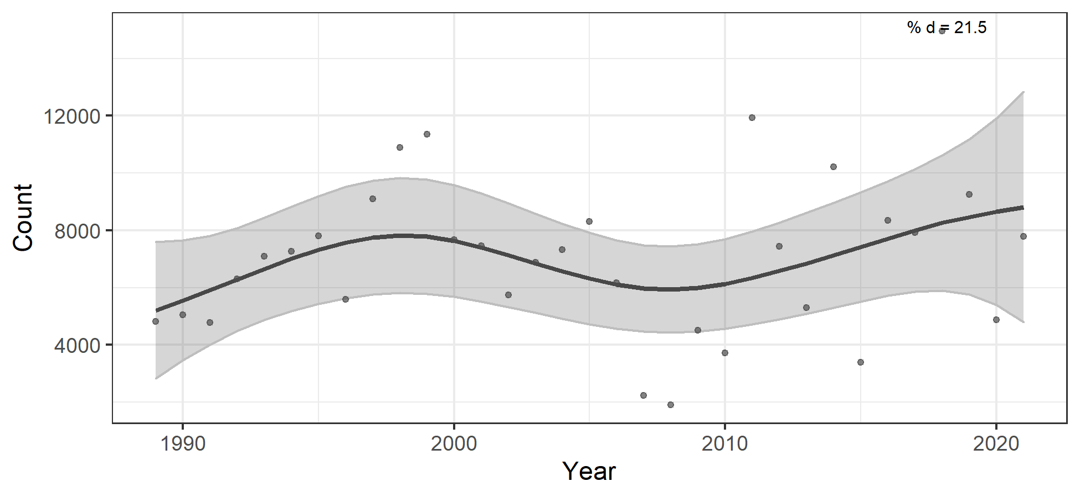



Figure 5. Trend in the population of Colorado butterfly plant (*Oenothera coloradensis*) at F. E. Warren Air Force Base, Cheyenne, Wyoming, 1989-2021; and on the three creek subpopulations, using GAM. The curvilinear trends (black line) from GAM are shown with 95% confidence band (grey shading) and annual population counts (points). There were no significant periods of increase or decrease except long-term decrease on Crow Creek 1999-2005) and long-term increase on Unnamed Creek. Percent deviance explained (% *d*) is a measure of effect size similar to *r*2 for linear models.

GAM analyses of COBP trends on creek segments were generated in 2022 and show different patterns at these different scales. Diamond Creek subpopulation segments showed a similar trend to the population as a whole, increasing through the late-1990s, decreasing through the late 2000s, then increasing again through 2021. The models for segments of Diamond Creek (Table 1, Figure 6) showed divergent patterns that ranged from an apparent increase at Segment 1 to a decrease at Segment 5. Abundance at Segment 4 of Diamond Creek varied widely, with significant periods of decrease in the early-2000s and increase in 2009-2011. The Unnamed Creek subpopulation showed a significant increasing trend that was approximately linear across the study period, from 734 plants in 1989 to 1,853 plants in 2021 (Figure 6). The overall trend for Unnamed Creek was significant and had a moderate effect size (Table 1). The trend for Segment 1 showed no significant periods of change, while the trend at Segment 2 increased significantly from 1993-2002, reaching a high of 4,438 plants in 2003 (Figure 6, Table 1).

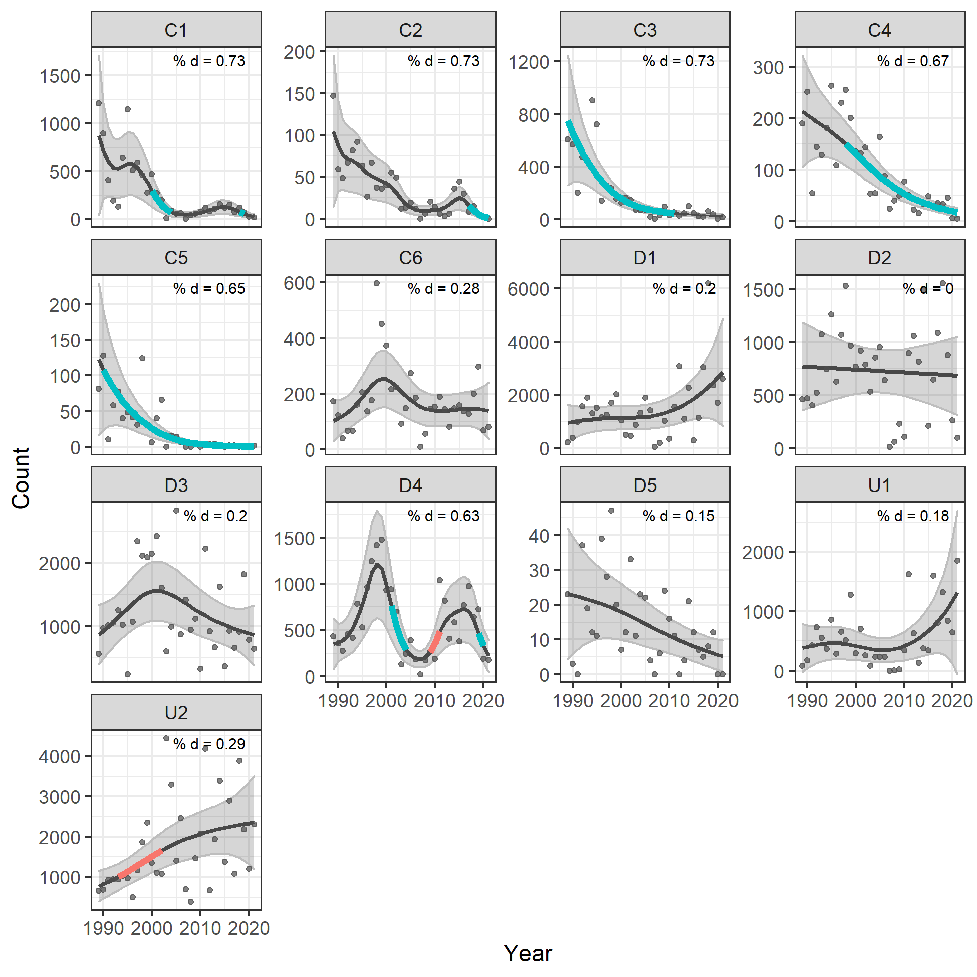

Figure 6. Trends in creek subpopulation segments of Colorado butterfly plant (*Oenothera coloradensis*) on Crow Creek (C), Diamond Creek (D), and Unnamed Creek (U) at F. E. Warren Air Force Base, Cheyenne, Wyoming, 1989-2021. Plots show curvilinear trends (lines) from generalized additive models with 95% confidence bands (grey shading), annual counts (points), and significant periods of increase (bold red lines) and decrease (bold blue lines). Percent deviance explained (% *d*) is a measure of effect size similar to *r*2 for linear models.

Table 1. Summary statistics for generalized additive models of trends in populations of Colorado butterfly plant (*Oenothera coloradensis*) at F.E. Warren Air Force Base, Wyoming, 1989-2021. Shown are data for the population, creek subpopulations, and creek segments (population column); *p*-value for the smoothed effect of year (*p*) indicating if trends are significantly curvilinear compared to linear; effective degrees of freedom estimated in the model (edf) indicating the complexity of the curvilinear trend; and the percent deviance explained (% *d*) as a measure of effect size similar to *r*2 in linear models.

|  |  |  |
| --- | --- | --- |
| Population | p | edf |
| Full | 0.235 | 3.297 |
| Crow Creek | <0.001 | 3.898 |
| Diamond Creek | 0.092 | 3.812 |
| Unnamed Creek | 0.001 | 1 |
| Crow Creek - Segment C1 | <0.001 | 5.947 |
| Crow Creek - Segment C2 | <0.001 | 6.865 |
| Crow Creek - Segment C3 | <0.001 | 2.241 |
| Crow Creek - Segment C4 | <0.001 | 2.127 |
| Crow Creek - Segment C5 | <0.001 | 1.692 |
| Crow Creek - Segment C6 | 0.177 | 3.562 |
| Diamond Creek - Segment D1 | 0.075 | 2.02 |
| Diamond Creek - Segment D2 | 0.793 | 1 |
| Diamond Creek - Segment D3 | 0.116 | 2.53 |
| Diamond Creek - Segment D4 | <0.001 | 7.037 |
| Diamond Creek - Segment D5 | 0.027 | 1.496 |
| Unnamed Creek - Segment U1 | 0.169 | 2.532 |
| Unnamed Creek - Segment U2 | 0.002 | 1.859 |

In addition to these long-term monitoring results, more recent demographic analysis has shown that… (Stears 2022).

Finally, there were finer-scale trend differences on separate segments of the three creeks despite their hydrological similarities. For example, if we look at just the data since 2002, a segment of occupied habitat on Crow Creek has increasing COBP numbers, despite widespread declines in the other segments. Crow Creek has had its greatest COBP declines in the upstream reaches in Segments 1 and 3. COBP population numbers on Diamond and Unnamed creeks have compensated for COBP declines on Crow Creek. The COBP plants recently discovered in lower Crow Creek (Segment 8) may represent an ephemeral COBP colonization or distribution expansion on FEWAFB.

# DISCUSSION

The FEWAFB population is a large, extensive population among all COBP populations, with hydrologically diverse habitat compared to populations with fragmented habitat. It has been treated as a single dataset in running the Mann-Kendall tests used in PDM metrics. We recommend running the Mann-Kendall tests used in PDM metrics for the separate creeks, and for random and deliberately-selected time intervals of five or more years by creek, as surrogates for longer-term datasets and small populations to determine the range of outcomes as reflecting on the PDM analysis.

The GAM analyses are a data-driven representation of population and subpopulation trends as compared to arbitrary decadal periods used in the linear regression analyses. The log(Lamda) analysis points to a mechanism of negative density-dependence that poses interesting questions in COBP population ecology.

Unnamed Creek showed prolonged COBP subpopulation growth despite wide variation in census counts from year to year. Unnamed Creek subpopulation sizes approach those of Diamond Creek, yet the area of occupied habitat in this drainage is the smallest of the three creeks and it has perhaps the most uniform of habitat. The high density and growth of this subpopulation place a premium on maintaining habitat conditions suitable for COBP on Unnamed Creek. The upper end was trenched in 2022 below road construction. This had the apparent effect of moving greater water volumes into occupied habitat that persisted at deeper levels than past years. Both of the Unnamed and Diamond Creeks settings show a succession toward native vegetation in the post-drought years.

Crow Creek had a consistent pattern of COBP subpopulation decline. The exception is in one section (C6) that is the most isolated from influence of streamflow, and the most sheltered of segments. The possibility that the COBP subpopulation on Crow Creek is influenced by water management practices outside the Base warrants further consideration. The overall trend of this subpopulation may be related to conditions that are unique to the creek. Crow Creek is the only one of the three creeks influenced by municipal water use, and has sandier soil textures that do not retain moisture as long in the growing season in the upper soil profile compared to the other two creeks. The concurrent change from a short stature shrub cover to tall shrub thicket cover may coincide with an effective lowering of the water table in the latter part of the growing season, and conversion of prevailing vegetation.

COBP population and subpopulation numbers on FEWAFB exhibit fluctuations that require multiyear datasets to distinguish growth or decline from stochastic oscillation. It has been documented that COBP has a seed bank, which confers life history resilience. One might expect a seed bank to have adaptive value by providing a buffer against temporal and spatial environmental fluctuation. However, the COBP subpopulation with the greatest levels of fluctuation is Unnamed Creek, with some of the most homogeneous of habitat. A comparison of COBP datasets on FEWAFB with those of other populations (Crystal Strouse pers. comm., Julie Reeves pers. comm.) indicate that COBP flowering plant numbers on FEWAFB have among the least variation from year to year of any monitored population. It is possible that idle conditions on FEWAFB are associated with lower variability in general, as well as with different creek population segments compensating for one another.

What do COBP trends mean for FEWAFB?

* They place a premium on maintaining local hydrological conditions, including surface management practices as basic as maintaining culverts and runoff, and addressing beaver dams with COBP in mind.
* The Crow Creek subpopulation might be affected as much or more by hydrological conditions outside of FEWAFB compared to inside FEWAFB.
* Management of riparian woodland, shrubland and weed cover may also affect COBP numbers whether by water availability or light availability, and by direct or indirect influence.

Population scenarios using Population Viability Analysis (PVA) modeling were prepared to simulate prolonged population and subpopulation trends associated with weather intervals from monitoring years for extended periods into the future. These simulations support population resilience through 2040 (Wepprich 2021), but do not factor in climate change. A revised PVA that addresses climate change might be relevant to the Post-Delisting Monitoring process.

## 2023 Monitoring plans

COBP monitoring work on FEWAFB will start in early August 2023. Flea beetle herbivory and midsummer mortality will be checked in advance if hot, dry conditions prevail. We support research communication, coordination and collaboration with others in Colorado and Wyoming who are monitoring and managing COBP.

# ACKNOWLEDGEMENTS

Monitoring and analysis of COBP trends continued in 2022 under a cooperative agreement between the U.S. Fish and Wildlife Service and Wyoming Natural Diversity Database with the coordination of Alex Schubert and Pamela Sponholtz, and the support of the F. E. Warren Air Force Base (WAFB; U.S. Air Force, Department of Defense). Coordination in prior years was provided by Tim Grosch, John McKinley, Jennifer Howenstine, Lori Ford, Cathryn Pesenti, Tom Smith, Walt Lenz and Bill Metz in the Environmental Element, Francis E. Warren Air Force Base.

Annual census monitoring of COBPon WAFB was planned and conducted by Wyoming Natural Diversity Database (WYNDD) as initiated by Hollis Marriott (1986-1992), and pursued by Walter Fertig (1993-2000), with the help of many other botanists through the years. Hollis

Marriott kindly provided her perspectives and insights during a revisit to the Base in 2014.

Population viability analysis was conducted in 2021 by Tyson Wepprich (Oregon State University), with 2019 collaboration of Daniel Laughlin (University of Wyoming) and WYNDD. Early calculations of Pearson’s correlation coefficient and Spearman’s rank coefficients with climate variables was first performed in 2003 by Scott Laursen (WYNDD) followed by repeat testing of Pearson’s correlation coefficients and added multiple regressions in 2004 and 2005 by Laura Hudson (WYNDD).

This monitoring project benefited from the pilot monitoring of COBP that was conducted by Robert Dorn and Robert Lichvar (Mountain West Environmental Services), the demographic monitoring and separate management response research conducted by Sandra Floyd and Tom Ranker (Colorado State University), and the management response research of Linda Munk, Leah Burgess and Ann Hild (University of Wyoming).

Alex Schubert (FWS) provided review of this report in draft form. Earlier reports likewise benefited from reviews by Julie Reeves (FWS), Tim Grosch (FWS), John McKinley (WAFB), Jennifer Howenstine (WAFB), Lori Ford (WAFB), Cathryn Pesenti (WAFB), Gary Beauvais (WYNDD), and Ken Gerow (University of Wyoming). The discussions, information exchanges and consultations with all researchers working on COBP are gratefully acknowledged.

# LITERATURE CITED

Brown, G. 1999. Exploratory molecular characterization of *Gaura neomexicana* ssp.

*coloradensis* - variability in the F. E. Warren Air Force Base populations. Report prepared for F. E. Warren Air Force Base by the Dept. of Botany, University of Wyoming, Laramie, WY.

Brown, G. 2000. Inter-simple Sequence Repeat (ISSR) variation in three populations of *Gaura neomexicana* ssp*. coloradensis*, F. E. Warren Air Force Base, Cheyenne, Wyoming. Report prepared for F. E. Warren Air Force Base by the Dept. of Botany, University of Wyoming, Laramie.

Curtis, C.J. and G.L. Simpson. 2014. Trends in bulk deposition of acidity in the UK, 1988–2007, assessed using additive models. Ecological Indicators 37:274-286.

Fertig, W. 2000. Status review of the Colorado butterfly plant (*Gaura neomexicana* ssp.

*coloradensis*). Report prepared for the Wyoming Cooperative Fish and Wildlife Research Unit, US Fish and Wildlife Service, and Wyoming Game and Fish Department by the Wyoming Natural Diversity Database, Laramie.

Floyd, S. K. 1995. Population structure, dynamics, and genetics of *Gaura neomexicana* ssp.  *coloradensis* (Onagraceae), a rare semelparous perennial. Master Thesis, Dept. of

Environmental, Population, and Organismic Biology, University of Colorado, Boulder.

Floyd, S.K. and T. Ranker. 1998. Analysis of a transition matrix model for *Gaura neomexicana*  ssp. *coloradensis* (Onagraceae) reveals spatial and temporal demographic variability.

International Journal of Plant Sciences 159 (5): 853-863.

Gerber, L. and M. Gonzalez-Suarez. 2010. Population viability analysis: origins and contributions. Nature Education Knowledge 3(10): 15-18.

Heidel, B. 2007. 19-year population trends of a short-lived riparian species, Colorado butterfly plant (*Gaura neomexicana* ssp. *coloradensis*; Onagraceae) on F. E. Warren Air Force Base, Laramie County, Wyoming. Prepared for the U.S. Air Force by the Wyoming Natural Diversity Database, Laramie.

Heidel, B. and J. Handley. 2011. 23-year population trends of Colorado butterfly plant (*Gaura neomexicana* ssp. *coloradensis;* Onagraceae), a short-lived riparian species on F. E. Warren Air Force Base. Prepared for F. E. Warren Air Force Base by the Wyoming Natural Diversity Database (University of Wyoming), Laramie, WY.

Heidel, B., L. Tronstad and J. Handley. 2011. Flea beetle (*Altica* spp.) herbivory on a threatened plant, F. E. Warren Air Force Base, Wyoming. Natural Areas Journal 31: 283-287.

Heidel, B., J. Handley and D. Tuthill. 2019. 31-year population trends of Colorado butterfly plant (*Oenothera coloradensis*; Onagraceae), a short-lived riparian species on F. E. Warren Air Force Base. Prepared for U.S. Fish and Wildlife Service and F. E. Warren Air Force Base by the Wyoming Natural Diversity Database (University of Wyoming), Laramie, WY.

Heidel, B., D. Tuthill and Z. Wallace. 2020. 32-year population trends of Colorado butterfly plant (*Oenothera coloradensis*; Onagraceae), a short-lived riparian species on F. E. Warren Air Force Base. Prepared for U.S. Fish and Wildlife Service and F. E. Warren Air Force Base by the Wyoming Natural Diversity Database (University of Wyoming), Laramie, WY.

Heidel, B., D. Tuthill and Z. Wallace. 2021. 33-year population trends of Colorado butterfly plant (*Oenothera coloradensis*; Onagraceae), a short-lived riparian species on F. E. Warren Air Force Base. Prepared for U.S. Fish and Wildlife Service and F. E. Warren Air Force Base by the Wyoming Natural Diversity Database (University of Wyoming), Laramie, WY.

Heidel, B., D. Tuthill and Z. Wallace. 2022. 34-year population trends of Colorado butterfly plant (*Oenothera coloradensis*; Onagraceae), a short-lived riparian species on F. E. Warren Air Force Base. Prepared for U.S. Fish and Wildlife Service and F. E. Warren Air Force Base by the Wyoming Natural Diversity Database (University of Wyoming), Laramie, WY.

Marriott, H. 1988. Monitoring of Colorado butterfly plant (*Gaura neomexicana* ssp.

*coloradensis*) on F. E. Warren Air Force Base, 1984-1988. Report prepared for the US Air Force by the Wyoming Natural Diversity Database, Laramie.

R Core Team. 2014. R: a language and environment for statistical computing. R Foundation for Statistical Computing, Vienna, Austria.

Raven, P.H. and D.P. Gregory. 1972. A revision of the genus *Gaura* (Onagraceae). Memoirs Torrey Botanical Club 23:1-96.

Stears, A. E. 2022. Trait-based plant demographic response to environmental change. PhD Dissertation. Department of Botany, University of Wyoming, Laramie.

Stevenson, A. 1997. Soil survey of Laramie County, Wyoming – western half. United States Department of Agriculture, Natural Resource Conservation Service. U.S. Government Printing Office, Washington, D.C.

Tuthill, D.E. and G.K. Brown. 2003. Inter-simple sequence repeat (ISSR) variation in three populations of *Gaura neomexicana* ssp. *coloradensis* (Onagraceae), F. E. Warren Air Force Base, Cheyenne, Wyoming. Western North American Naturalist 63(2):251-257.

USDI Fish and Wildlife Service. 2000. Endangered and Threatened wildlife and plants:

Threatened status for the Colorado butterfly plant (*Gaura neomexicana* ssp. *coloradensis*) from southeastern Wyoming, northcentral Colorado, and extreme western Nebraska. Federal Register 65(202):62302-62310 by Mary Jennings. USDI Fish and Wildlife Service. 2010. Recovery outline for *Gaura neomexicana* ssp. *coloradensis* (Colorado Butterfly Plant). Posted electronically at: <http://ecos.fws.gove/tess_public/pub/listedPlants.jsp>.

U.S. Fish and Wildlife Service. 2019. Endangered and Threatened Wildlife and Plants; Removing *Oenothera coloradensis* (Colorado Butterfly Plant) From the Federal List of Endangered and Threatened Plants. 84, No. 214: 59570-59588.

USDI Geological Survey. 1989. National Water Summary 1988-1989 – Floods and Droughts: WYOMING, posted electronically by the U.S. Geological Survey at: <https://www.usgs.gov/centers/wy-mt-water/>.

USDI Geological Survey. 2018. Water resources site inventory for USGS stream gauge 06755960 on Crow Creek at 19th Street in Cheyenne, WY posted electronically by the U.S. Geological Survey at: [http://waterdata.usgs.gov/wy/nwis/inventory/?site_no=06755960.](http://waterdata.usgs.gov/wy/nwis/inventory/?site_no=06755960)

USDI National Oceanic and Atmospheric Administration – Western Regional Climate Center. 2022. Mean monthly temperature and precipitation data for Cheyenne, Wyoming. Posted electronically at: <https://wrcc.dri.edu/cgi-bin/cliMAIN.pl?wy1675> [Downloaded 2022].

Wepprich, T. et al. In progress. Population models and forecasts using long-term monitoring data for a recently delisted riparian forb, *Oenothera coloradensis* (Colorado butterfly plant.

Wood, S.N. 2011. Fast stable restricted maximum likelihood and marginal likelihood estimation of semiparametric generalized linear models. Journal of the Royal Statistical Society (B) 73:3-36.

1. 2021 is the 34rd consecutive year of monitoring at FEWAFB beginning in 1988, though monitoring data was not collected at the scale of creek segments until 1989, a scale used for PVA analysis. The first year of data collecting was in 1986, making this the 35th year of data collecting.